HOT & SPICY

PIZZA

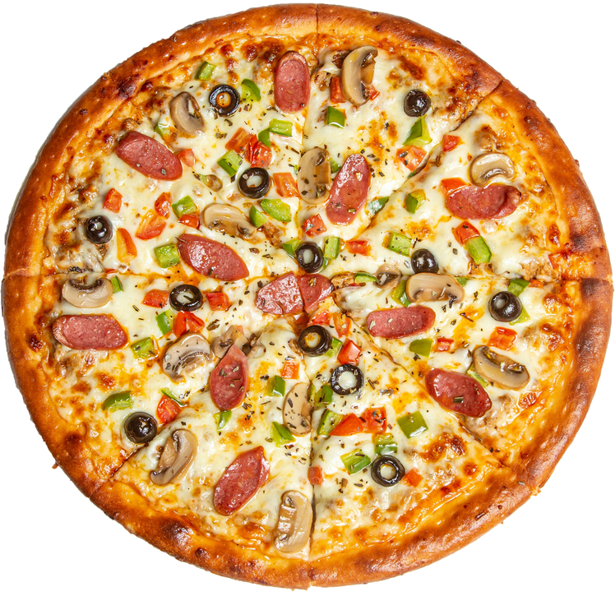

50% OFF

ORDER NOW!

**Shivam Sujan**

**This SQL project analyzes pizza sales data to uncover trends, improve inventory management, and enhance customer satisfaction. Key metrics include sales volume, peak times, and popular toppings.**

**1. RETRIEVE THE TOTAL NUMBER OF ORDERS PLACED**

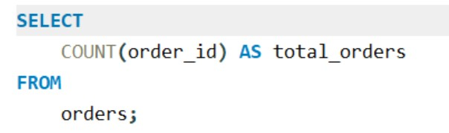

OUTPUT:

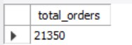

**2 .CALCULATE THE TOTAL REVENUE GENERATED FROM PIZZA SALES.**

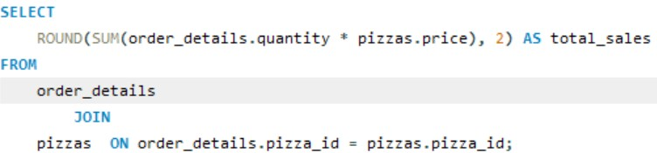

OUTPUT:

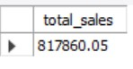

1. 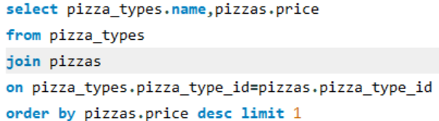**IDENTIFY THE HIGHEST-PRICED PIZZA.**

OUTPUT:

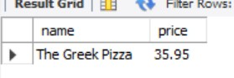

1. **IDENTIFY THE MOST COMMON PIZZA SIZE ORDERED.**

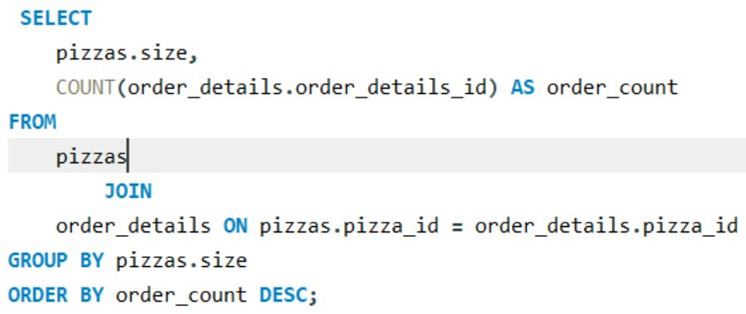

OUTPUT:

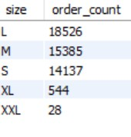

1. **LIST THE TOP 5 MOST ORDERED PIZZA TYPES ALONG WITH THEIR QUANTITIES.**

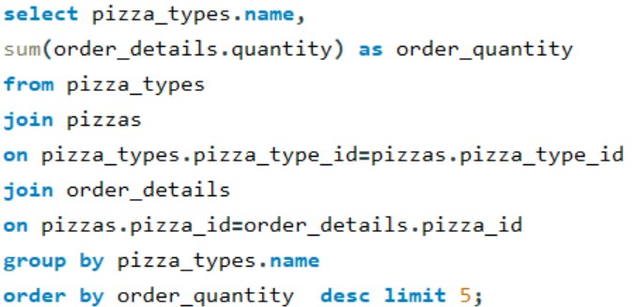

OUTPUT:

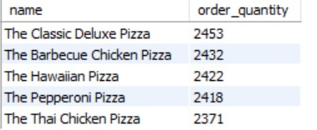

1. 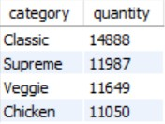**JOIN THE NECESSARY TABLES TO FIND THE TOTAL QUANTITY OF EACH PIZZA CATEGORY ORDERED.**

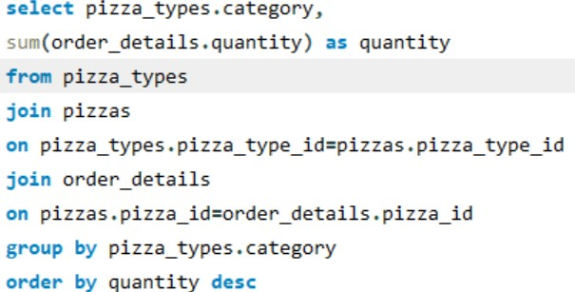

OUTPUT:

1. **DETERMINE THE DISTRIBUTION OF ORDERS BY HOUR OF THE DAY.**

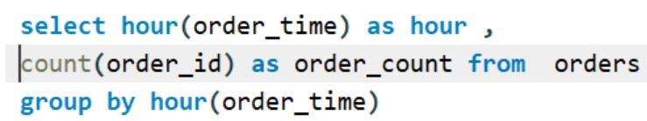

OUTPUT:

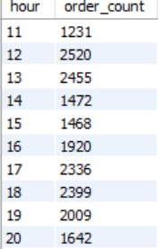

1. **JOIN RELEVANT TABLES TO FIND THE CATEGORY-WISE**

DISTRIBUTION OF PIZZAS.

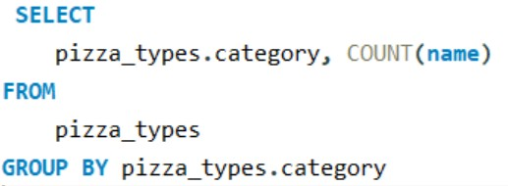

OUTPUT:

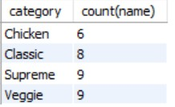

1. **GROUP THE ORDERS BY DATE AND CALCULATE THE AVERAGE NUMBER OF PIZZAS ORDERED PER DAY.**

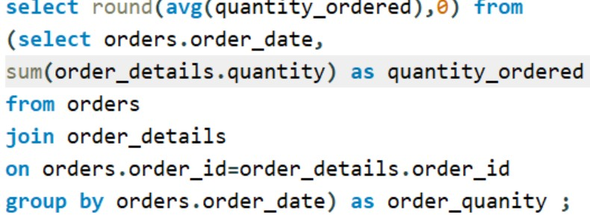

OUTPUT:



1. **DETERMINE THE TOP 3 MOST ORDERED PIZZA TYPES BASED ON**

REVENUE.

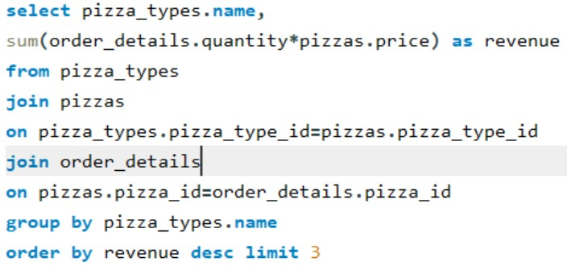

OUTPUT:

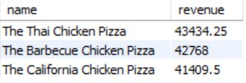

1. **CALCULATE THE PERCENTAGE CONTRIBUTION OF EACH PIZZA TYPE**

TO TOTAL REVENUE.

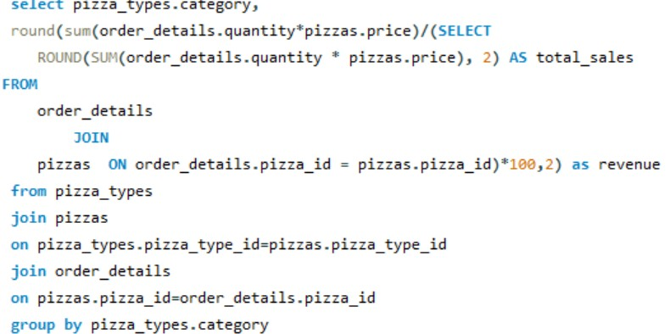

OUTPUT:

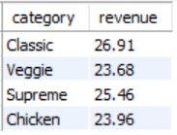

1. 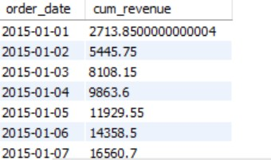**ANALYZE THE CUMULATIVE REVENUE GENERATED OVER TIME.**

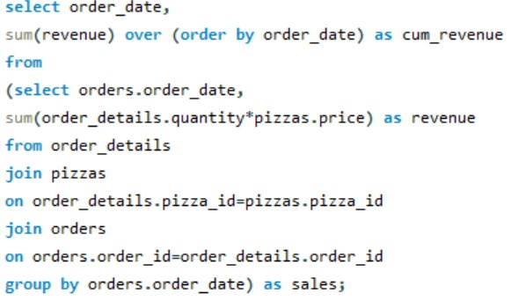

OUTPUT:

THANK YOU !!